# IMT – Worksheet 1

Define the following concepts:

1. Repository

A repository is a location which contains all relevant folders and files specific to a project. The repository also contains a revision history detailing any and all changes made to the project files.

An example of a repository on GitHub web page.

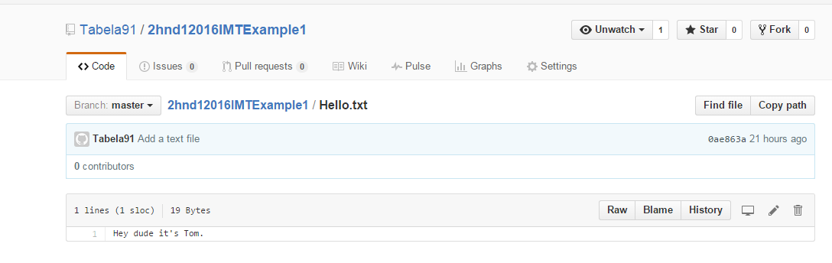

2.) Commit

Committing is the act of saving any changes made to local files to the master folder

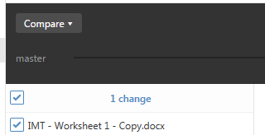

The local GitHub App will display a list of changes it detected to the folders and files in the project folder. These changes can then be committed to the master folder.

3.) Commit description

Before committing changes to the master, you have the option to give a summary and description to each detected change. This makes it easier to keep track of changes made to the project over time.

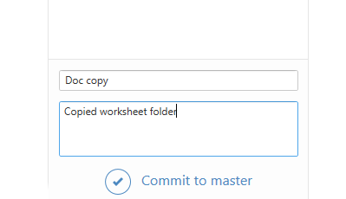

4.) GitHub desktop

This is an application which allows you to track and manage changes made to a project locally. The app works seamlessly with the GitHub website, allowing you to commit and document changes made to the project.



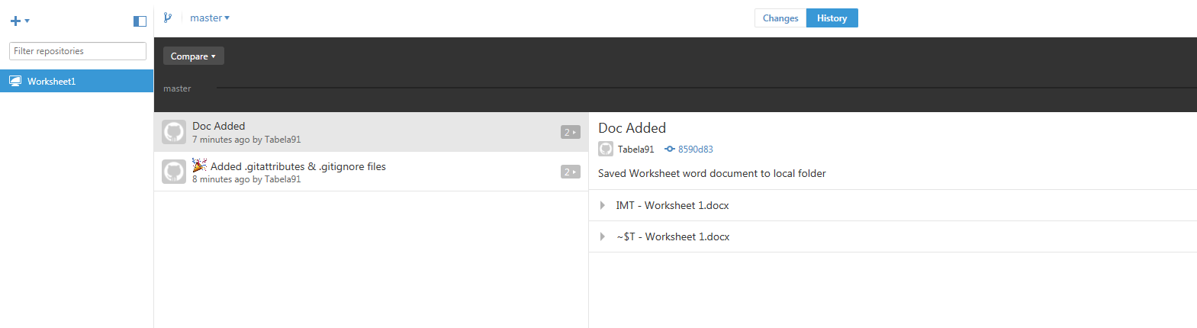

5.) Git Sync

Syncing is when the application ensures that the project folders on both the local machine and on the website are identical. It saves changes made to the local folder to the online folder and vice versa.

6.) Download ZIP



This will download a zipped copy of the project folder contained within the selected repository to the local machine. This can be used to makes changes to the project locally or offline and then have those changes committed to the online repository later.